Task 1: System Monitoring Setup
Desc: Install and configure htop or nmon to monitor CPU, memory, and processes, using df and du for disk usage tracking, and identifying resource-intensive processes. Proper logging of system metrics and clear documentation of the setup are essential.
Solution:
Prerequisites:
- Install htop using
  - command: sudo apt install -y htop
- Install nmon
  - command: sudo apt install -y nmon
Script to log system metrics at regular intervals – ref - system_metrics.sh
cron job:
Configure cron job to run system_metrics.sh every five minutes.
Command: crontab -e
> Input: */5 * * * * /usr/local/bin/system_metrics.sh (Save and exit)
Sample output:
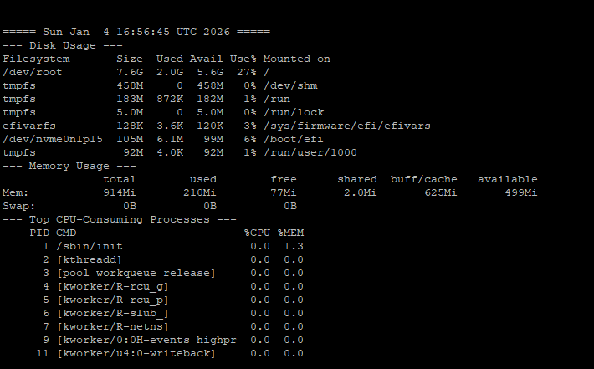

Task 2: User Management and Access Control
Desc: Evaluation includes creating user accounts for Sarah and Mike with secure passwords, setting up isolated directories with appropriate permissions, and enforcing a password policy with expiration and complexity. Detailed documentation of user management steps is required.

Solution:
1. Configure password complexity using PAM:
Command: sudo nano /etc/security/pwquality.conf (edit this file and add input as below)
Input:
minlen = 8 (minimum length)
dcredit = -1 (At least 1 digit)
ucredit = -1 (At least 1 uppercase letter)
lcredit = -1 (At least 1 lowercase letter)
ocredit = -1 (At least 1 special character)

2. User creation:
sudo useradd -m Sarah
sudo useradd -m Mike

3. Assign temp password to users:
sudo passwd Sarah
sudo passwd Mike
4. Force user to change password when they first login and set expiry date (30 days):
sudo chage -d 0 -M 30 Sarah
sudo chage -d 0 -M 30 Mike

6. Create dedicated directories:
sudo mkdir -p /home/Sarah/workspace
sudo mkdir -p /home/Mike/workspace

7. Assign ownership of the directories to respective users:
sudo chown -R Sarah:Sarah /home/Sarah/workspace
sudo chown -R Mike:Mike /home/Mike/workspace

8: Assign Directory Permission to respective users:
sudo chmod 700 /home/Sarah/workspace
sudo chmod 700 /home/Mike/workspace

Task 3: Backup Configuration for Web Servers
Desc: Configure automated backups for Apache (/etc/httpd/, /var/www/html/) and Nginx (/etc/nginx/, /usr/share/nginx/html/), scheduling cron jobs to run every Tuesday at 12:00 AM, using the correct naming convention for backup files, and verifying backup integrity. Proper documentation and logs are necessary.
Overall Report and Presentation
The report should clearly summarize implementation steps and challenges, including relevant screenshots or terminal outputs demonstrating task completion.
Solution:
1. Create a centralized and secure backup directory:
sudo mkdir -p /backups
sudo chmod 700 /backups

2. Backup Script for Sarah (Apache Server) - Ref apache_backup.sh
Command to make the script executable: sudo chmod +x /usr/local/bin/apache_backup.sh
3. Backup Script for Mike (Nginx Server) - ref nginx_backup.sh
Command to make the script executable: sudo chmod +x /usr/local/bin/nginx_backup.sh

4. Scheduling Backups Using Cron:
Command: crontab -e
Entry for Apache Backup: 0 0 * * 2 /usr/local/bin/apache_backup.sh
Enty for Nginx Backup: 0 0 * * 2 /usr/local/bin/nginx_backup.sh
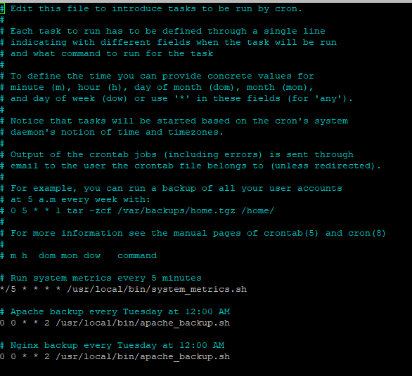

5. Logs location:
- /backups/apache_backup_verification.log
- /backups/nginx_backup_verification.log

6. Sample output:
- For Apache backup:
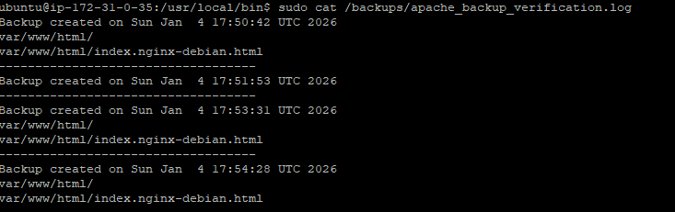
- For nginx backup:
